https://www.washingtonpost.com/business/2023/09/22/us-braces-calamitous-costly-government-shutdown-eight-days/
Accessibility statementSkip to main content
Democracy Dies in Darkness
SubscribeSign in
Advertisement
ECONOMIC POLICY

U.S. braces for costly government shutdown in eight days

Federal workers and military service members won’t be paid, while federal programs — from some food safety inspections to child care funds — come to an abrupt halt

By Tony Romm
Updated September 22, 2023 at 11:11 a.m. EDT|Published September 22, 2023 at 6:00 a.m. EDT

House Speaker Kevin McCarthy (R-Calif.) walks back to his office after votes on the House floor at the U.S. Capitol in Washington, D.C., on Wednesday. On Thursday, House lawmakers left the Capitol with seemingly no resolution in sight. (Elizabeth Frantz for The Washington Post)
Listen
10 min
Share
Comment3832
Millions of federal employees and active military service members will stop receiving paychecks — but many will be forced to report to work anyway.
Some national parks may close, museums could shutter and airports nationwide might see new disruptions and delays.
Get a curated selection of 10 of our best stories in your inbox every weekend.
And the most pivotal federal aid programs — including those assisting the victims of the deadly wildfires in Maui — could struggle to provide urgently needed support.
In only eight days, the U.S. government is set to shut down, unleashing real and wide-ranging financial hardship on American families, workers and businesses. The lapse in funding would mark a fundamental breakdown in an ever-divided, intransigent Washington, where lawmakers this year have struggled — time and again — to fulfill their most basic fiscal responsibilities.
Skip to end of carousel

The looming government shutdown: What to know
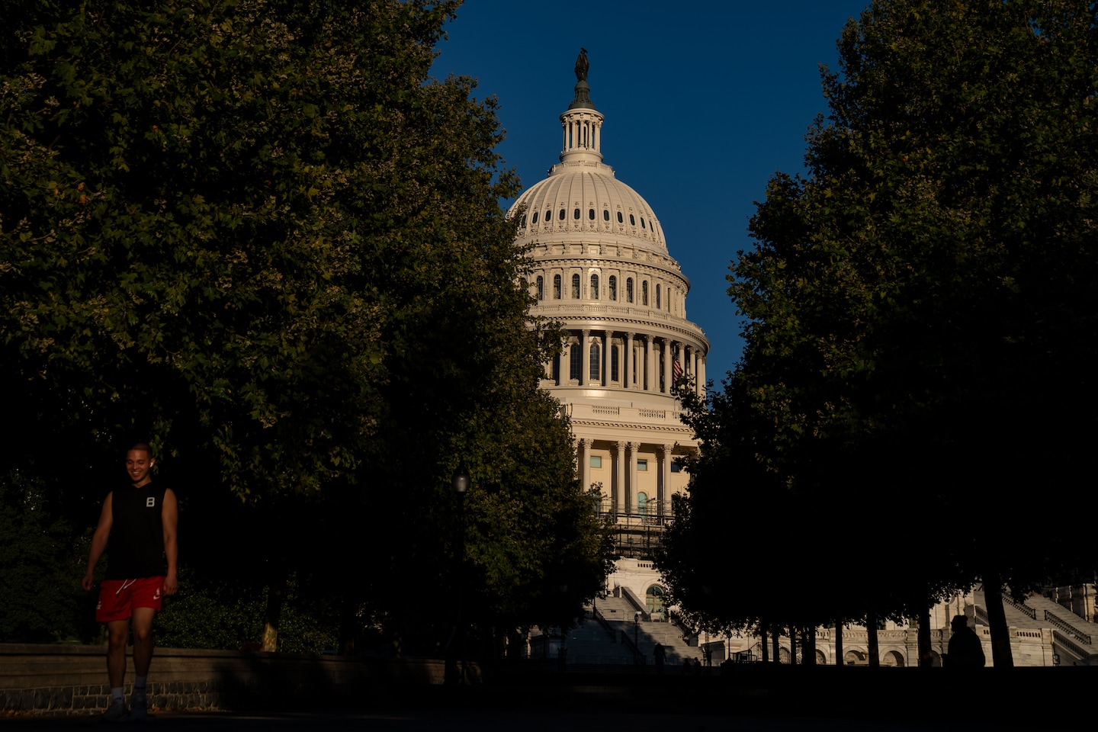The dome of the U.S. Capitol building is seen on Aug. 31. (Kent Nishimura/For The Washington Post)
House Republicans for the second week in a row failed to move forward on any legislation related to funding the government, further complicating efforts to avert a government shutdown ahead of the Sept. 30 deadline.
Here’s what we know about the possibility of a government shutdown and the longest government shutdown in U.S. history.
End of carousel
At the heart of the stalemate are renewed Republican demands for deep federal spending cuts, more than three months after House Speaker Kevin McCarthy (R-Calif.) finalized a deal with President Biden that was supposed to prevent this very brinkmanship. Far-right lawmakers have blocked the House this week from adopting a short-term measure that would sustain federal spending at its existing levels and buy more time for the two parties to work out a longer-term arrangement.
ADVERTISING
If Congress fails to resolve the impasse by Sept. 30, federal appropriations will expire, bringing many agencies to a halt and forcing the sprawling U.S. government to operate at a mere shell of itself. Anticipating the worst, the Biden administration has started to revise and publish a set of intricate blueprints for how agencies should proceed if funds run dry.
What happens during a government shutdown
2:31

Washington Post senior political reporter Rhonda Colvin breaks down what a government shutdown is and how the timing now could hurt the economy. (Video: The Washington Post, Photo: Michael S. Williamson/The Washington Post)
As usual, mail deliveries would continue, and seniors would still receive their Social Security checks, because they are not funded through annual appropriations. But older Americans might not be able to obtain new Medicare cards or address some other issues with their benefits until federal funding resumes.
Some federal inspections that ensure food safety and prevent the release of hazardous chemicals in drinking water would be halted, the Biden administration has warned. Federal research toward cancer cures and other innovative therapies would cease. Some passport offices would close if they are located in affected government buildings, potentially snarling some Americans’ plans for international travel.
And with each passing day, Washington would further deplete federal safety-net programs that carry over their unused money from past years. Eventually, the government may not be able to provide some poor families with child care, nutrition assistance, housing vouchers or college financial aid. The longer a shutdown persists, the greater the blow it could ultimately deliver to an economy that has teetered for more than a year on the precipice of recession.
“The solution is very, very simple. Extreme House Republicans need to stop playing political games with people’s lives,” White House press secretary Karine Jean-Pierre told reporters Thursday. “There’s so much at stake here.”
Poor families could see cuts to food aid as Congress battles over budget
For the moment, Congress continues to barrel toward another fiscal crisis, in a year that already saw the U.S. government almost default on its debt. Far-right Republicans have made clear that they are willing to use pivotal deadlines — and the threat of economic catastrophe — to extract policy concessions from Biden and, at times, pressure leaders of their own party. McCarthy has largely acquiesced to their demands, even directing committees this month to open an impeachment inquiry into Biden to appease restive conservatives.
On Thursday, House lawmakers departed the Capitol with seemingly no resolution in sight, raising the odds that the country is about a week away from what would be the 21st shutdown since 1977, when the U.S. shifted the start of its fiscal year to Oct. 1. The heaviest initial blow would fall on about 2.2 million federal employees, who would not receive pay for as long as appropriations lapse, said Jacqueline Simon, the policy director of the American Federation of Government Employees, the largest union of federal workers.
“Most Americans cannot go without a paycheck on payday,” she said. “The vast majority of our members cannot go even one pay period, let alone two, three, four pay periods, without a paycheck.”
Press Enter to skip to end of carousel

Government shutdown looms


A federal government shutdown looks more and more likely: What to know


U.S. braces for costly government shutdown in eight days

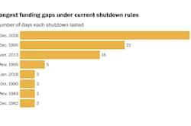
The shortest and longest government shutdowns in U.S. history

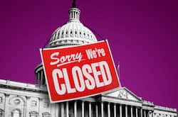
What to do if a federal government shutdown stops your paycheck
Advice

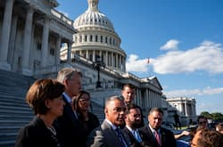
House Republicans falter on funding plans, as shutdown inches closer


White House watches House GOP dysfunction as government shutdown nears


House flounders as GOP fails to appease hard-right members on funding


House Republicans propose short-term funding deal that Senate likely to rej...


Speaker McCarthy steps into the breach as his conference toils

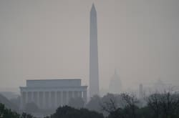
The federal government could shut down in October. Here’s how and why.

End of carousel
The immediate loss of income would arrive as prices remain elevated from high inflation over the past year, and just before the U.S. government is about to resume requiring borrowers to repay their student loans. Many federal workers would not have to report to their jobs, but the government is likely to deem hundreds of thousands of its employees as “excepted” from the shutdown because they deal with national security or public safety.
Even in a shutdown, the nation’s approximately 1.3 million active-duty troops would also helm their stations without pay. Once federal funding resumes, though, the government is required by law to repay federal employees and military personnel. Federal contractors, however, would not be compensated for missed time.
While the Pentagon retains broad latitude to continue programs in the name of national security, top defense officials in recent days have signaled that a shutdown next month could prove uniquely disruptive — even inhibiting their ability to provide some foreign military aid. That includes the supply of select materiel to Ukraine as it continues to fend off Russia, which some House Republicans oppose.
Appearing Tuesday on Capitol Hill, Mira Resnick, the deputy assistant secretary of state for regional security, stressed that prior shutdowns have left her agency “unable to process new foreign military sales for any partner,” except in emergencies, before imploring lawmakers: “This is something we would like to avoid.”
Biden seeks $16 billion in disaster aid as Idalia, wildfires deplete federal funds
The lapse in funding could prove just as debilitating for Americans outside of government, especially those who are still recovering from recent wildfires, hurricanes and other natural disasters.
The primary federal fund for disaster recovery has fallen to about $2.4 billion, a level that the Federal Emergency Management Agency has described as unsustainable amid hurricane season. In an ominous sign, FEMA spent more than that — about $2.6 billion — just in the first 30 days after Hurricane Ian struck Florida last year.
Share this articleShare
Last month, FEMA took the rare step to begin rationing its money, pausing about $1.5 billion in longer-term recovery projects to ensure it has enough cash on hand in the event of a major, deadly crisis, said Deanne Criswell, the agency’s administrator. Asked what might happen if those funds approach zero without new appropriations, Criswell told lawmakers at a hearing Tuesday that the consequences could be dire.
“Given our current state,” she said, the fund balance “would be insufficient to cover all of our ongoing lifesaving operations.”
What to do if a federal government shutdown stops your paycheck
The most recent interruption in federal funding occurred under President Donald Trump, a 35-day lapse in appropriations beginning in the waning hours of 2018 that marked the longest shutdown in U.S. history. Trump held up government funding into January 2019 in an attempt to force Democrats to fund construction of a wall along the U.S.-Mexican border.
Ultimately, Trump failed to secure the money as part of a deal to reopen the government in January, at which point the shutdown had already incurred great economic cost. That month, a federal budget watchdog estimated the political stalemate had delayed about $18 billion in government spending, while reducing gross domestic product by an estimated $8 billion that quarter and interrupting a vast swath of American life.
Nationally, air passengers at the time saw significant delays: Unpaid for a month, some inspectors at the Transportation Security Administration — the federal agents who check bags and protect flights — stopped coming to work “due to the financial toll of the shutdown,” a trio of top airline union groups said then. Four years later, the National Air Traffic Controllers Association renewed its plea for congressional action, warning Wednesday that the last shutdown imperiled “safety activities that proactively reduce risk,” before adding: “We cannot let history repeat itself.”
The exact economic effects of a shutdown may not be immediately evident, because some of the federal officials who produce and release data about inflation and unemployment might come to a stop as well. But a lapse in funding beyond a few weeks — on top of rising interest rates and other economic turbulence — could result in a “meaningful hit to growth,” predicted Mark Zandi, the chief economist at Moody’s Analytics.
“None of this is any good for the economy,” he said.
Two years after lawmakers approved a bipartisan bill to rejuvenate the economy and improve the country’s infrastructure, a failure to fund the government would leave it temporarily unable to approve some projects to improve the nation’s roads, bridges, pipes, ports and internet connections.
“It hamstrings federal agencies, and there are a lot of them doing infrastructure work,” said Maria Lehman, the president of the American Society of Civil Engineers. “There’s uncertainty on ongoing projects, [and] new projects can’t get underway.”
The U.S. would slow down its efforts to inspect workplaces for safety hazards, according to the White House, while the government would not be able to process new applications for loans to cash-starved small businesses. And federal agencies would face escalating challenges in providing critical economic support to Americans under financial duress.
Roughly 10,000 children would lose access to child care starting in October as a result of disruptions to Head Start, a program that provides grants to care organizations, according to the White House, which released its own estimate of shutdown implications on Wednesday. Without those grants, some of these child care centers likely would shutter, leaving parents struggling to balance family and work obligations.
The loss of funding would worsen what is already expected to be a child-care crisis this fall. Even if Congress does fund the government in time, lawmakers are not expected to renew pandemic-era funding that boosted child-care programs. That could result in the closure of 70,000 child care centers, totaling one in three nationally, starting next month, experts have said.
Child care is about to get more expensive, as federal funds dry up
At the start of any shutdown, the U.S. government could continue to pay out food stamps and other nutrition aid, provide housing vouchers to low-income families and process financial aid for the neediest college students. But federal agencies in recent days have signaled that they may have to dial back this support after October if the shutdown spans weeks or longer.
One of the programs — a food-and-vegetable benefit for women, infants and children known as WIC — may only be able to sustain its operations for a few days if federal appropriations lapse, according to the Agriculture Department. That could put roughly 7 million pregnant and postpartum women, infants and children up to age 5 at risk of benefit cuts that leave them hungry, the agency said Friday.
Some states, which manage WIC benefits, may have leftover funds that allow them to continue providing nutritional support even into a shutdown. But the relief is likely to prove short-lived, since the WIC program already faces a significant budget shortfall, a gap that prompted the Biden administration earlier this month to ask Congress for $1.4 billion in emergency aid.
Poor families could see cuts to food aid as Congress battles over budget
Sharon Parrott, the president of the left-leaning Center on Budget and Policy Priorities, pointed to the uncertainty as she acknowledged millions of families could be at risk if congressional inaction causes a lengthy government shutdown.
“The longer a shutdown lasts,” she said, “the more problems would emerge.”

